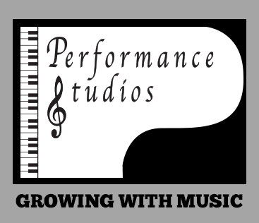
Summer Music Camp Registration
July 6-13 & August 17-24
9am-4pm
Camp Fee: $275 per child for a single week with $50
non-refundable deposit with the balance due on or before the first day of camp.
Reminder: Early drop off is 8-9am and late pick-up is 4-5pm.
Camper Name: _____________________________________________________________________
Address: _____________________________________________________ Age: ______________
Session (please circle your selection): July 6-13 Aug 17-24
Health Information: (i.e. Allergies/Food Sensitivities/Medical Conditions/Special instructions)
___________________________________________________________________________________
Health Card #: __ __ __ __ - __ __ __ - __ __ __ - ___ ___
Email: _______________________________________________________________________________
Parent/Guardian’s Name: _______________________________________________________________
Parent/Guardian’s Phone Number: _______________________________________________________
Please indicate if you require late pick-up and/or early drop off: (pricing is per child, per day)
Pick-up ($5) Drop off ($5) Both ($10) Neither
Payment options: E-transfer to performancestudiosfergus@gmail.com OR cheque payable to Performance Studios.
The undersigned, do hereby consent and agree that Performance Studios, its employees or agents have the right to take photographs, videotape or digital recordings of my child in his or her music camp(s) and to use these in any and all media, now or hereafter known, and exclusively for the purpose of advertising and promotion. I understand that my child’s name and identity will not be revealed therein or by descriptive text or commentary. I do hereby release to Performance Studios its agents and employees all rights to exhibit this work in print and electronic form publicly or privately and to produce copies. I waive any rights, claims or interest I may have to control the use of their likeness in whatever media used. I understand that there will be no financial or other remuneration for recording them, either initial or subsequent transmission or playback in perpetuity. I also understand that Performance Studios is not responsible for any expense or liability incurred as a result of their participation in the camp, including medical expenses due to any sickness or injury incurred as a result. I understand that the facility is not guaranteed to be allergen free and therefore assume all risks for the registrant pertaining to allergies and medical conditions.

Signed _____________________________________________________________________________________

